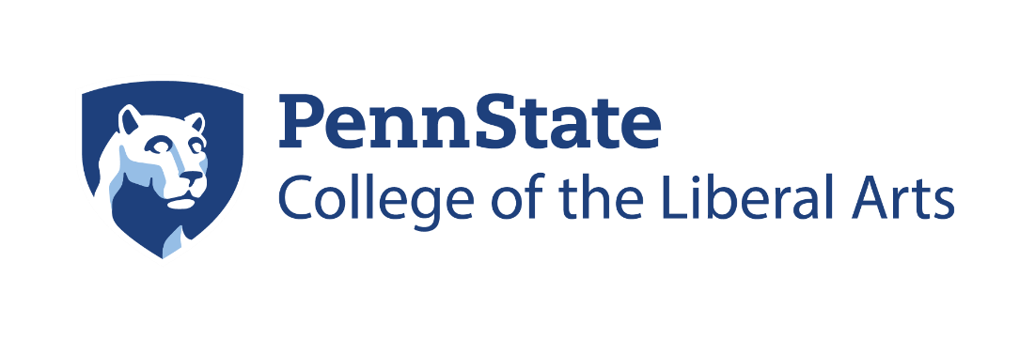

2021–22
Germanic and Slavic
Languages and Literatures
Awards Ceremony

Monday, April 25, 2022
4:00 p.m.
Pasquerilla Spiritual Center

Opening Remarks: Daniel Purdy, Department Head

Introduction by
Richard Page, Associate Dean for Undergraduate Studies in the College of the Liberal Arts
for
Alumni Award: Carolyn Mudrinich Weiss ’81

“The Importance of Learning a Language for Your Career”

German Awards

Graduate Announcements (Samuel Frederick)

Anna Piotti Denise Haunani Solomon Outstanding
Teaching Award for Graduate Students

Hannah Matangos RGSO Dissertation Fellowship

Katherine Kerschen Lecturer/Pedagogy Specialist in the
Department of Germanic Languages and Literatures at Washington University in St. Louis

Jack Dimidio Award from the Gerald E. and Martha M. Kightlinger Family Program

Michael McLaughlin Award from the Gerhard F. Strasser
Graduate Endowment

Dylan Rose Award from the Gerhard F. Strasser Graduate Endowment

German Undergraduate Awards

Stanley R. Townsend Memorial Award in German:

Amanda Neyhart (Forrest Finch)

L.V.T. Simmons Award in German:

Cecelia Bacon (Daniel Purdy)

Gerhard Strasser Award for Best Academic Performance by a German B.A.:

Elliott Salvatori in Berlin

Helen Adolf Award for Best Academic Performance by a
German Minor:

Abigail Wagner (Bettina Brandt)

Zertifikat Deutsch

Ava Kidd
Elliott Salvatori
Sydney McQuiggan

Graduating German Majors
Jessica Jablonski
Corina Kaiser
Ava Rysewyk
Marcelle Thomas
Nicholas Wanner
Graduating German Minors
Cecelia Bacon
Robert Baumback
Ross Campanella
Dominic Ciocca
Amanda Clark
Maulik Gupta
Aubrey McElrath
Ryan Middlemore
Leah Mullen
Aidan Onest
Alexander Palmer
Jean Paul Scarbrough
Kiara Smith
Abigail Wagner
Patrick Walsh
Max Weissberger

Student Marshals

German Student Marshal

Jessica Jablonski (Bettina Brandt)

Russian Student Marshal

Will Baumgardner (Irina Mikaelian)

Ukrainian and Russian Awards

Outstanding Senior Award:

Stephanie Heighton (Irina Mikaelian)

Sigmund S. Birkenmayer Memorial Award:

Zane Saylor (Irina Mikaelian)
Ryan Zalewski (Yuliya Ladygina)

Julianne and David Vaughan Scholarship for Russian Study

Demetrius Merkey (Yelena Zotova)
Katherine Fowler (Adrian Wanner)
Hannah Scholze (Yuliya Ladygina)

Joseph Paternost and James Gebhard Award in Russian in the College of the Liberal Arts:

Nicholas Birosik (Adrian Wanner)

William and Anna Naydan Award for Excellence in
Ukrainian Studies:

Maria Smereka
Ryan Weast (Michael Naydan)

American Council of Teachers of Russian Post-Secondary Russian Scholar Laureate Award:

Stephanie Heighton (Irina Mikaelian)

Dobro Slovo, the National Slavic Honor Society:

Hannah Scholze and Nicholas Birosik (Adrian Wanner)

Graduating Russian Majors

William Baumgardner
Stephanie Heighton
Vlad Hilling
Nicholas Magera

Graduating Russian Minors

Jose Cartagena
Madison Jack
Hannah Scholze
Mikaela Walker

Faculty Accomplishments

Thank you for working together under pandemic conditions, with specific gratitude to--

Carrie Jackson for taking over as interim department head after having been an Administrative Fellow

Sara Henneböhl for her promotion to Associate Teaching Professor

Yuliya Ladygina for the renewal of a Helena Rubenstein University Endowed Fellow in the Humanities

Bettina Brandt for College of Liberal Arts Outstanding Teaching Award for Teaching Faculty, for serving as the director of undergraduate studies and for receiving the senior fellowship at the International Research Center for Cultural Studies in Vienna

Julia Goetze for starting as an assistant professor at the University of Wisconsin, Madison. We and the students of the German Club will miss her.

Forrest Finch for continuing as our colleague in the department

Irina Mikaelian for returning from her research leave

Mike Putnam for directing linguistics

Tom Beebee for his continued advice to and engagement with the department even as prepares to ride off into the sunset.

Sam Frederick for climbing into the director of graduate studies role and for the publication of his book, The Redemption of Things

Adrian Wanner for organizing the Slavic program

Kobi Kabalek and Yuliya Ladygina for receiving Humanities Institute fellowships

Michael Naydan for mobilizing support for Ukraine

Jens Guettel for his award from the National Endowment for the Humanities

Sharon Munger-Wailes for directing the World Campus courses

Sabine Doran for her strength and health

Yelena Zotova whose book Wingless Desire in Modernist Russia was shortlisted for 2022 AATSEEL Best Book in Literary Studies Prize

And, most vitally, thanks to Bill Whitesmith for his hard work in hustling through the paperwork that allows the graduate program to run.

This publication is available in alternative media on request. Penn State is an equal opportunity, affirmative action employer, and is committed to providing employment opportunities to all qualified applicants without regard to race, color, religion, age, sex, sexual orientation, gender identity, national origin, disability or protected veteran status. U.Ed. LBS 22-486

